**DS LAB FILE MAIN**

**1.ARRAY-SUM AND AVERAGE**

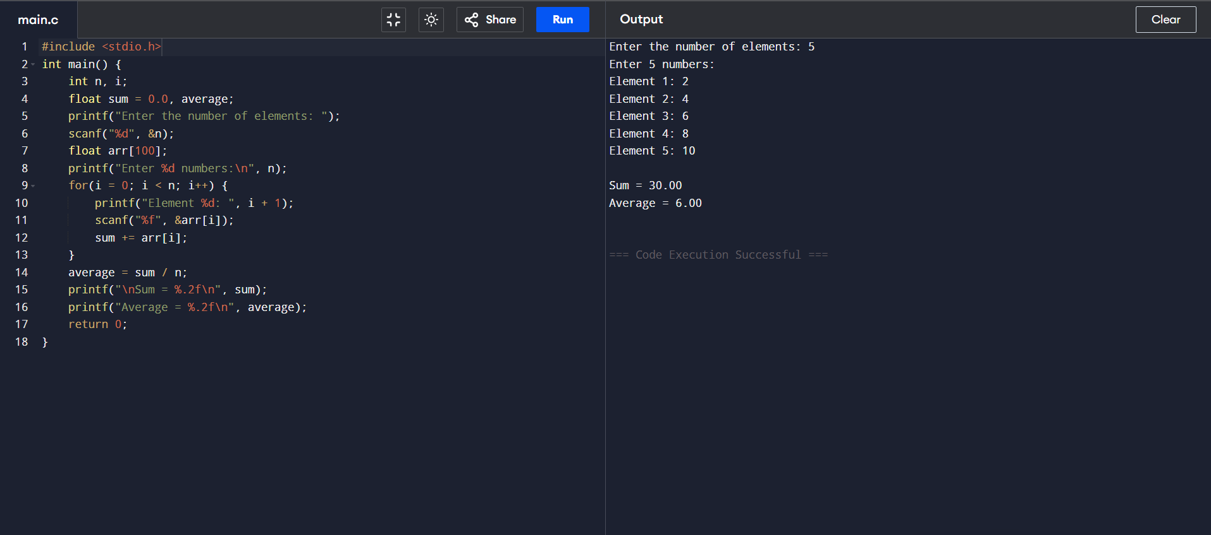

**SAMEER (24/SCA/BCA/042)**

**2.TRAVERSING IN ARRAY**

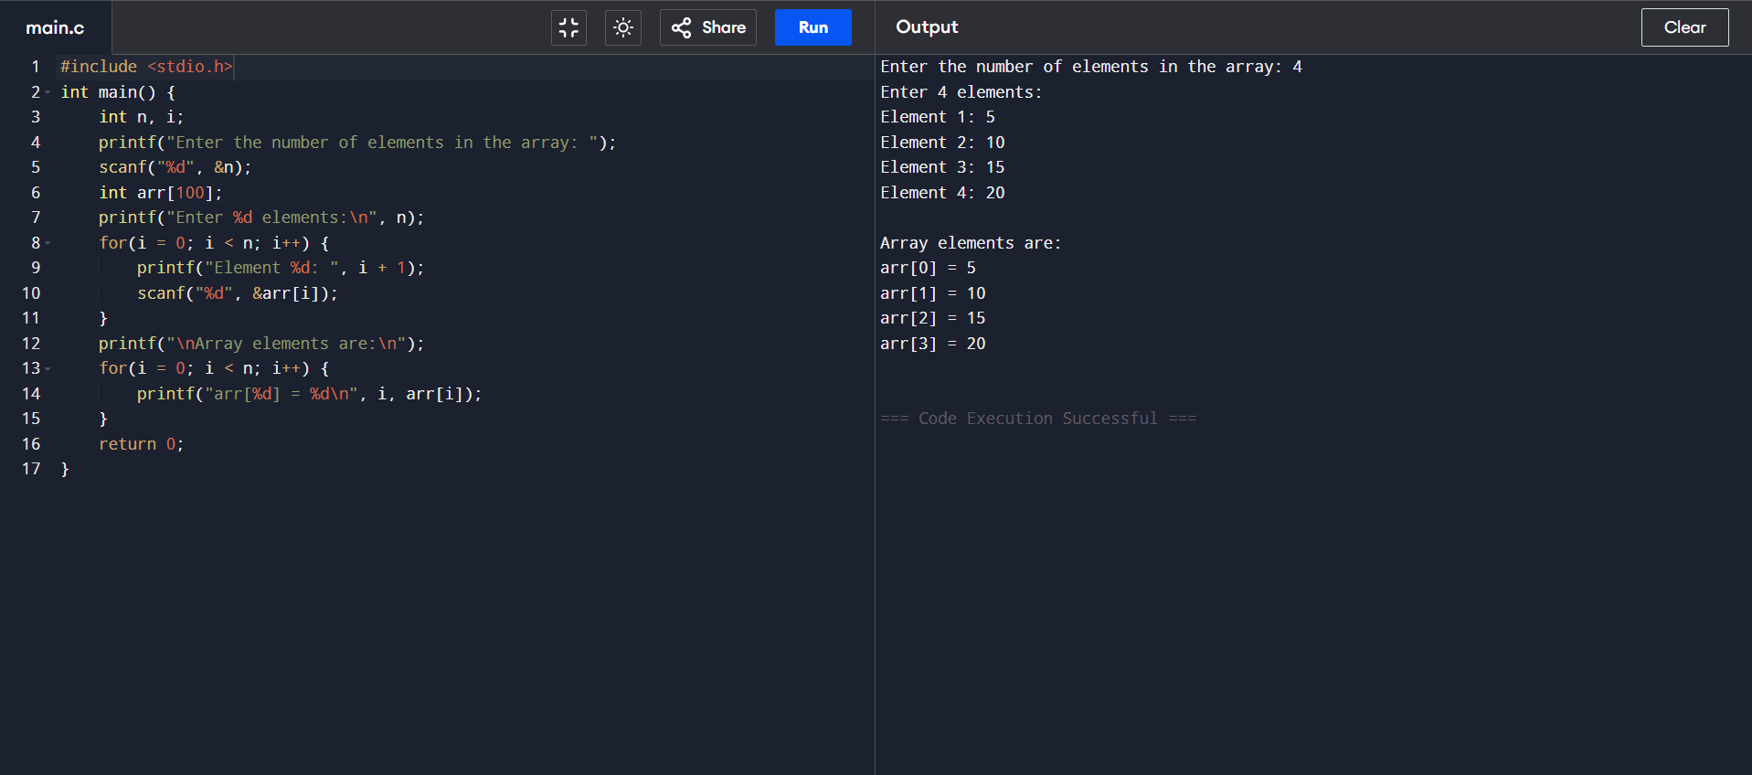

**SAMEER (24/SCA/BCA/042)**

**3.INSERTION IN ARRAY**

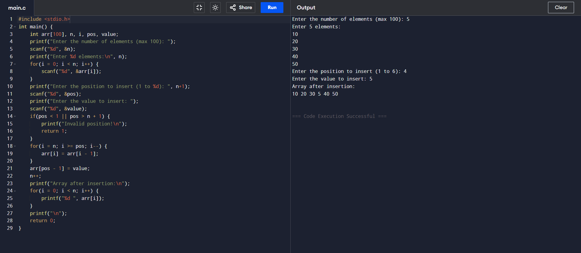

**SAMEER (24/SCA/BCA/042)**

**4.DELETION IN ARRAY**

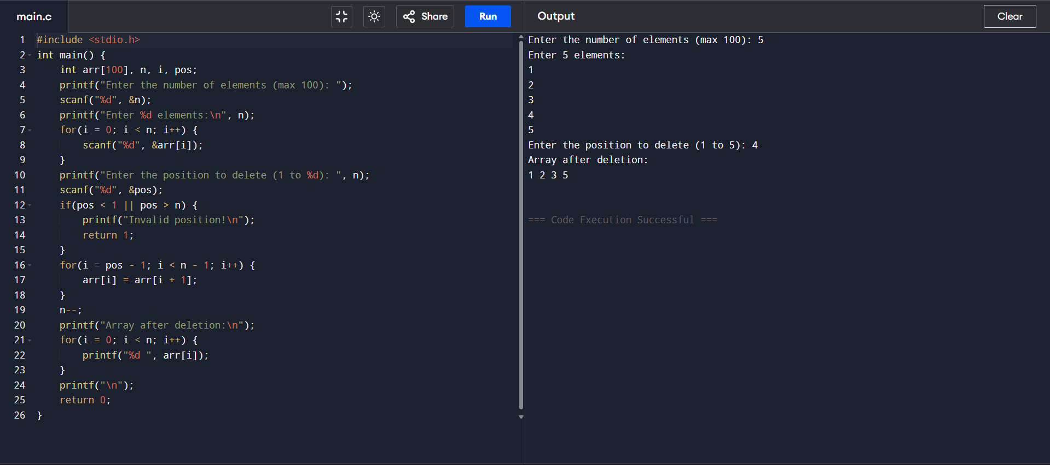

**SAMEER (24/SCA/BCA/042)**

**5.BINARY TO DECIMAL**

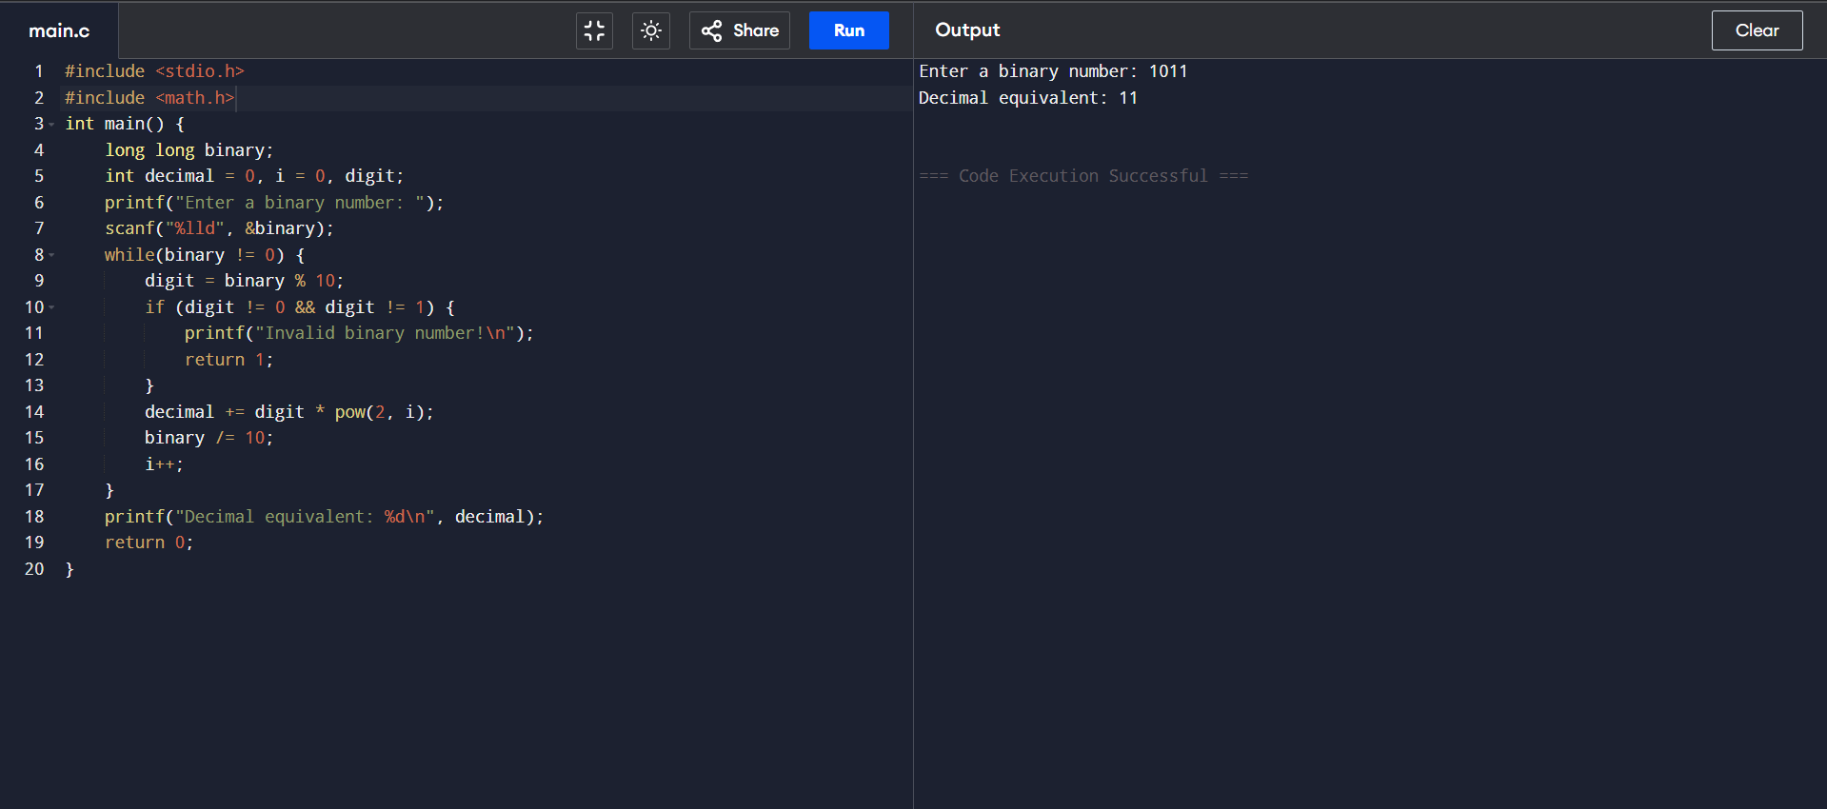

**SAMEER (24/SCA/BCA/042)**

**6.2D MULTIPLICATION IN ARRAY**

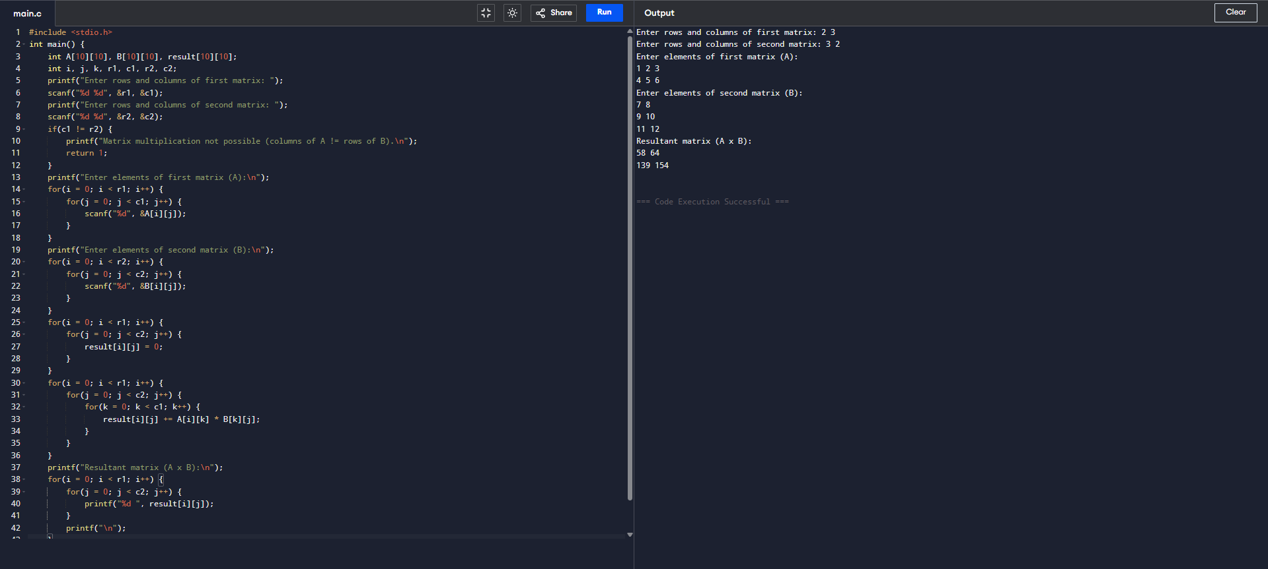

**SAMEER (24/SCA/BCA/042)**

**7.TRANSPOSING IN ARRAY**

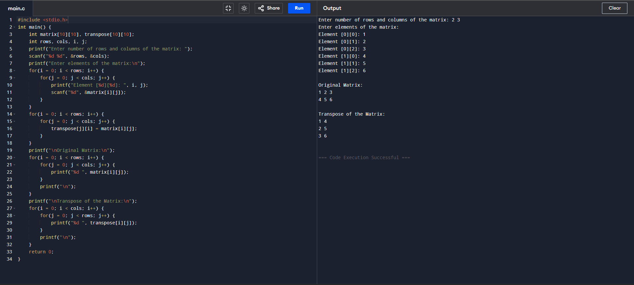

**SAMEER (24/SCA/BCA/042)**

**8.STACK OPERATION-PUSH AND POP**

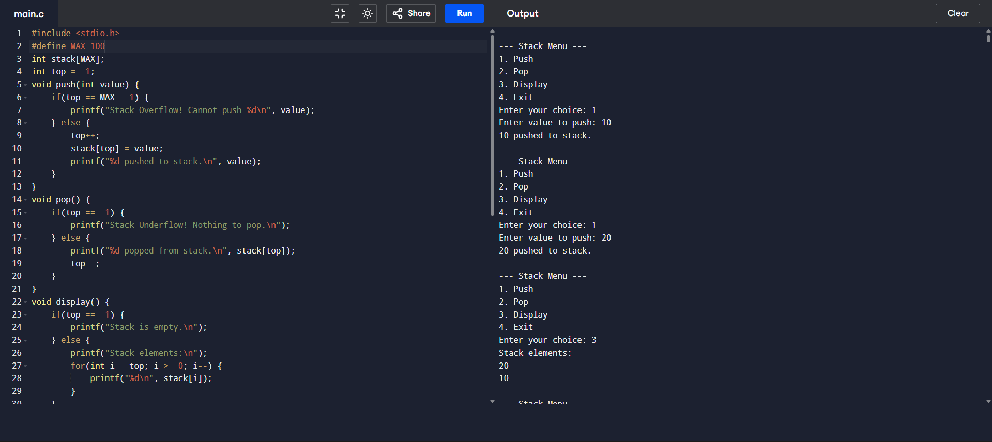

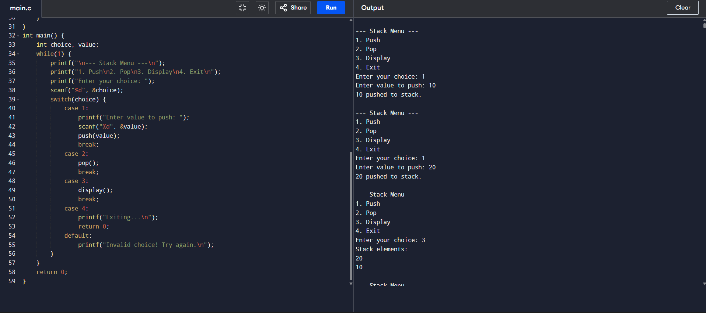

**SAMEER (24/SCA/BCA/042)**

**9.QUEUE OPERATION-INSERTION DELETION DISPLAY**

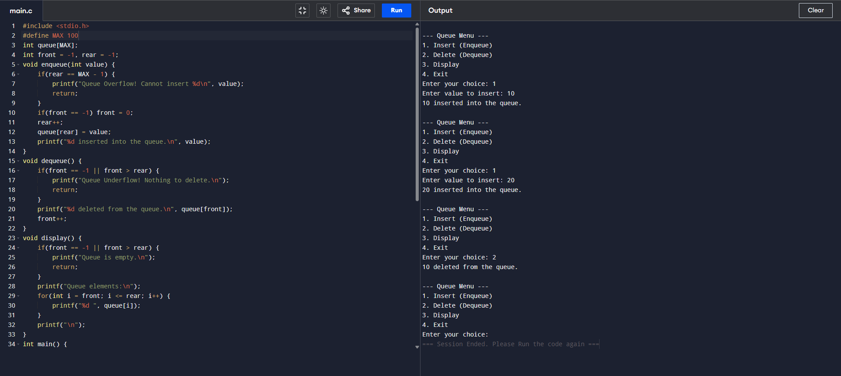

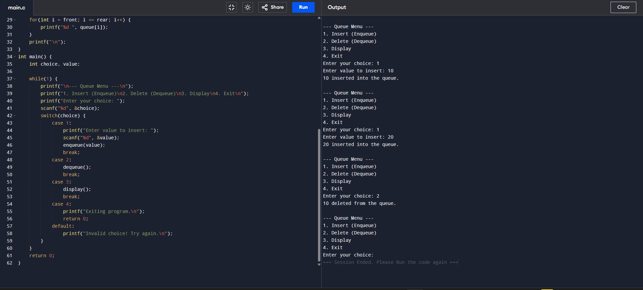

**SAMEER (24/SCA/BCA/042)**

**10.LINKLIST OPERATION-INSERTION DELETION DISPLAY**

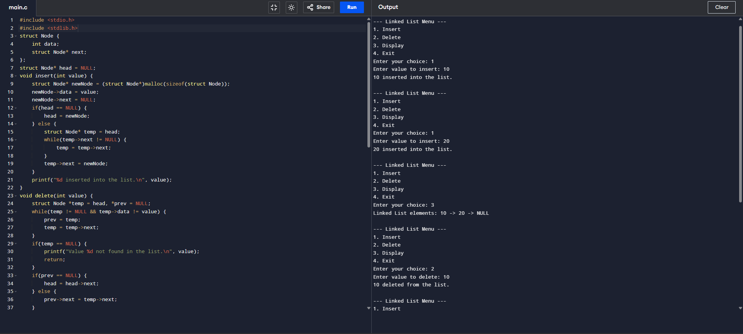

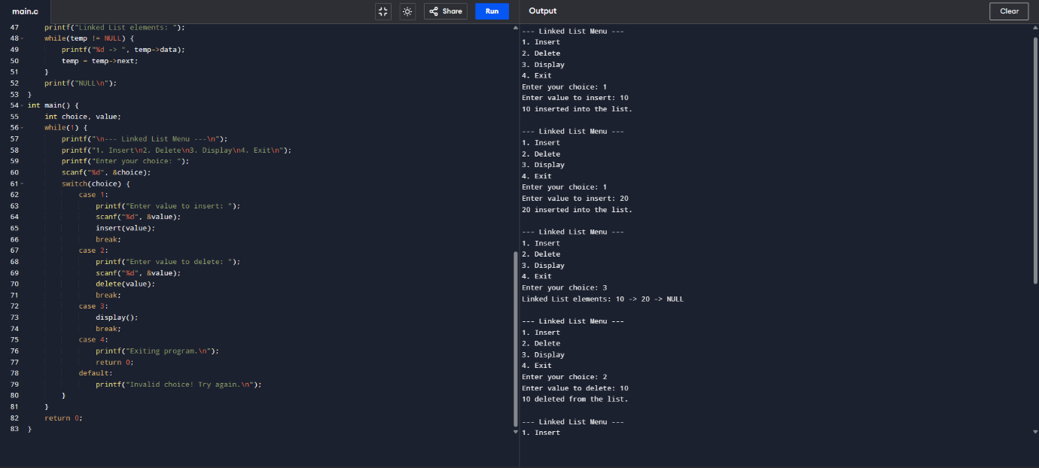

**SAMEER(24/SCA/BCA/042)**

**11.STACK THROUGH LINKLIST-PUSH POP DISPLAY**

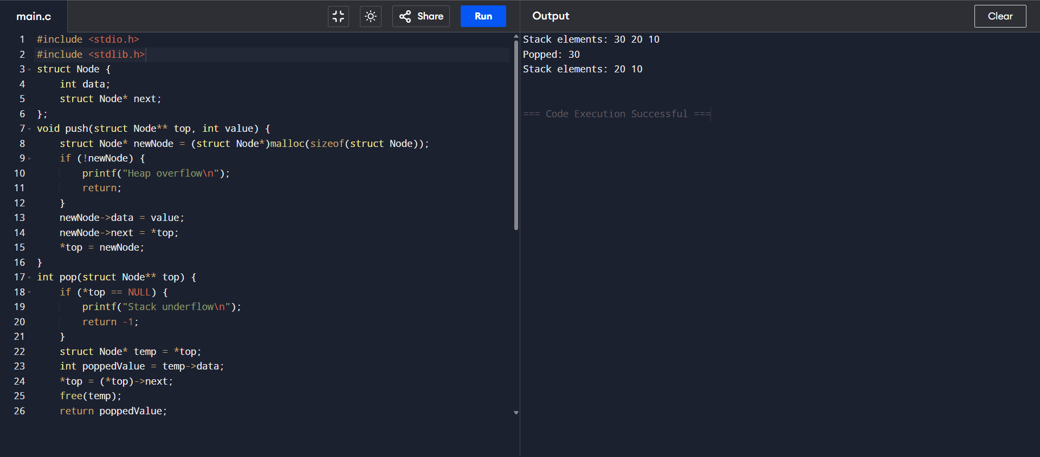

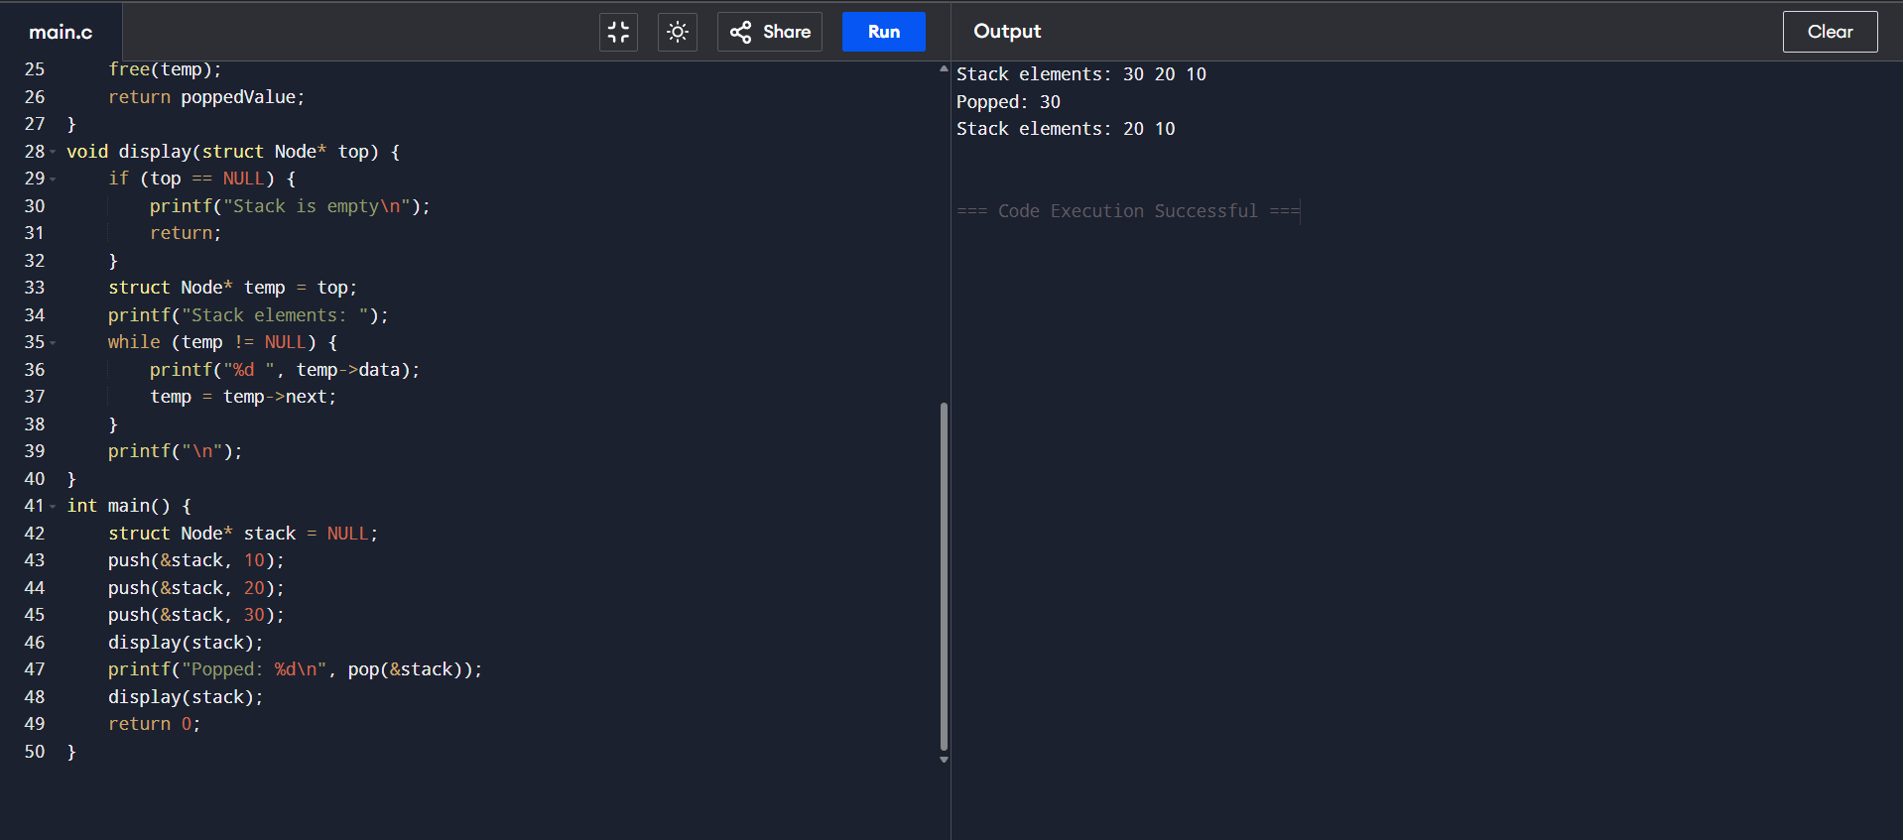

**SAMEER (24/SCA/BCA/042)**

**12.QUEUE THROUGH LINKLIST-INSERTION DELETION DISPLAY**

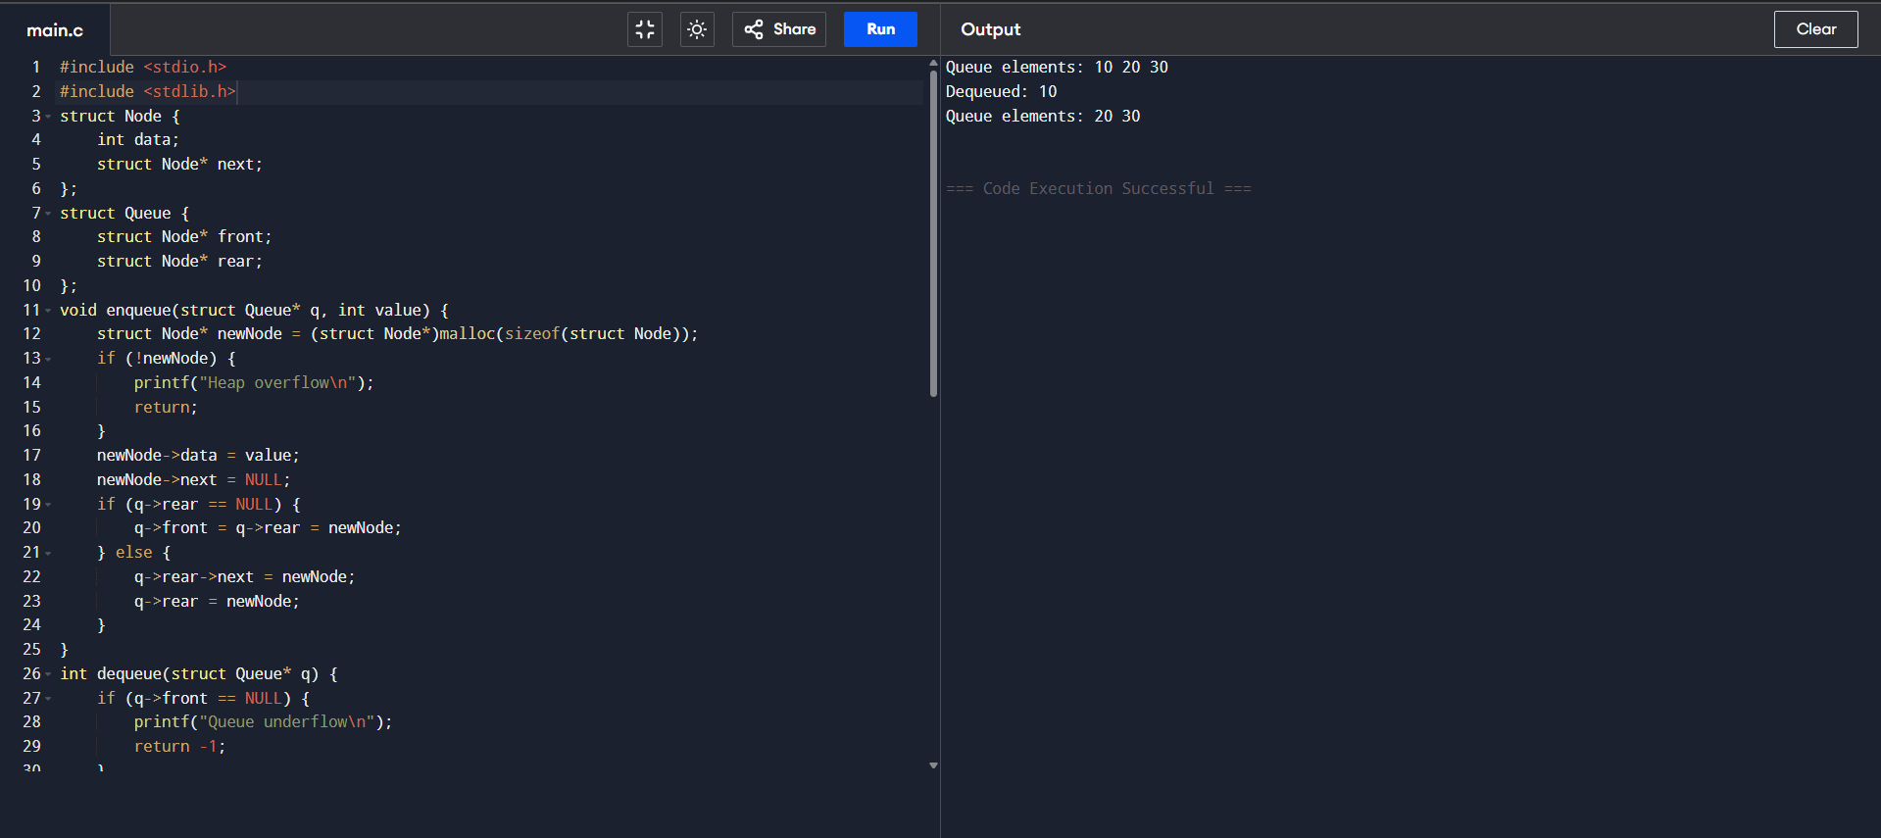

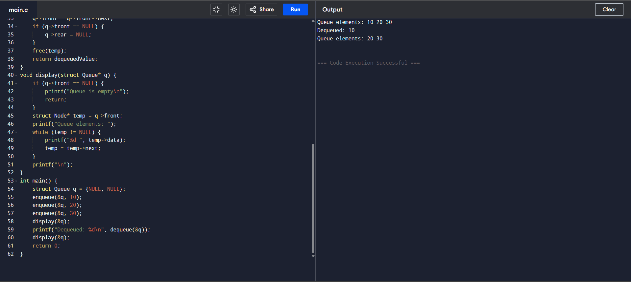

**SAMEER (24/SCA/BCA/042)**

**13.TREE TRAVERSAL**

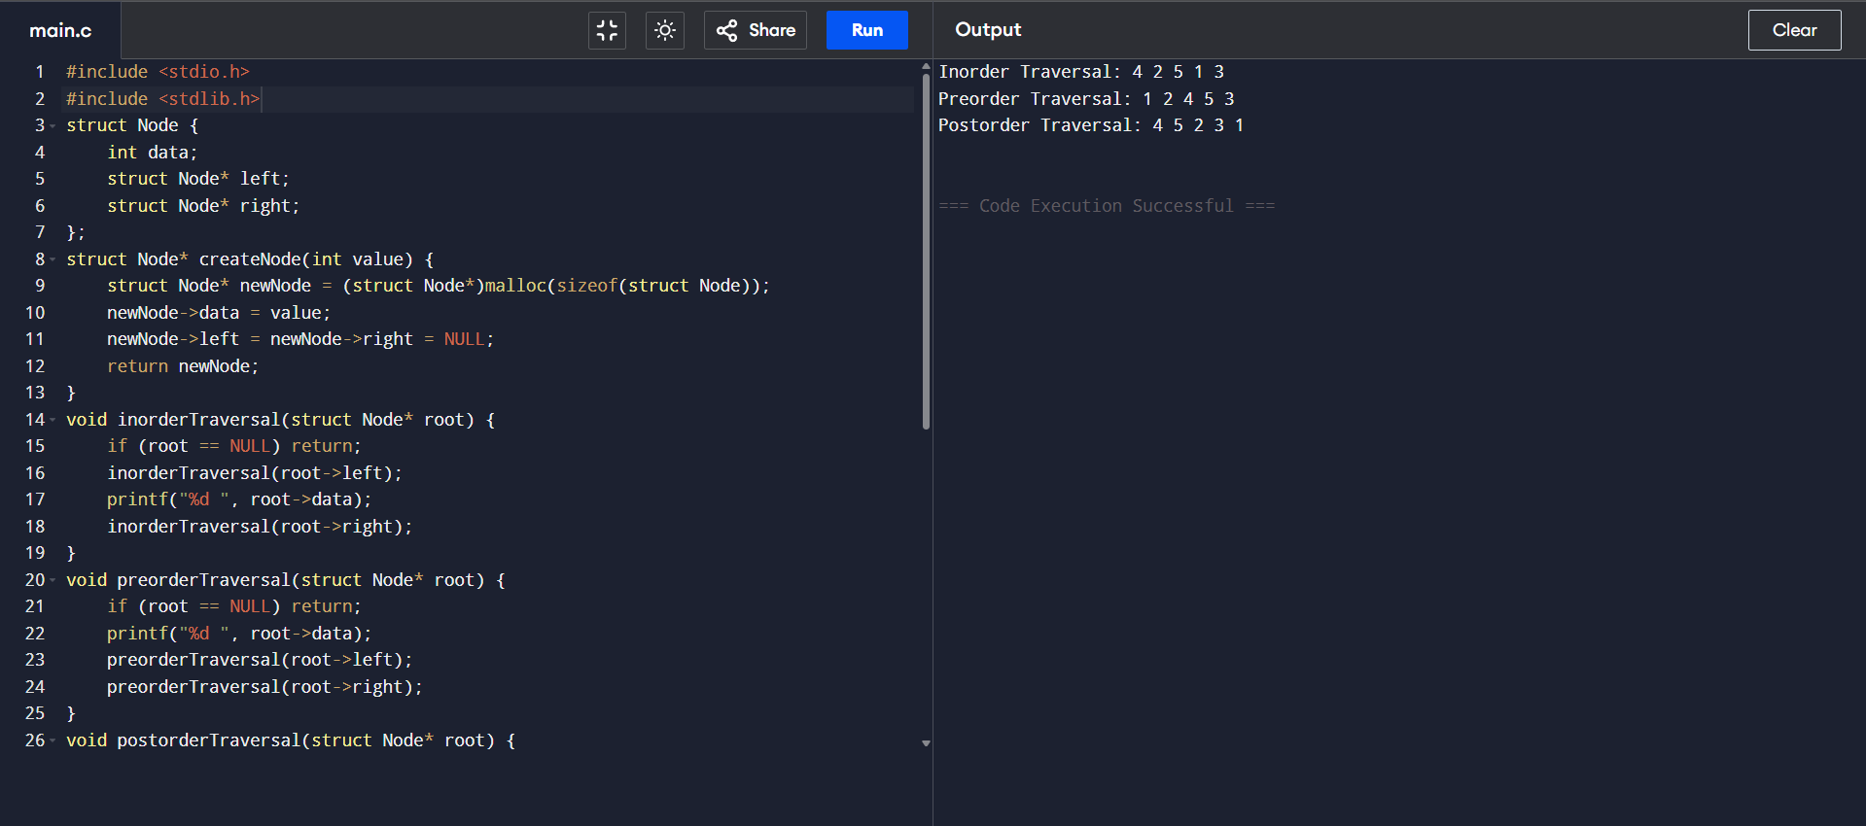

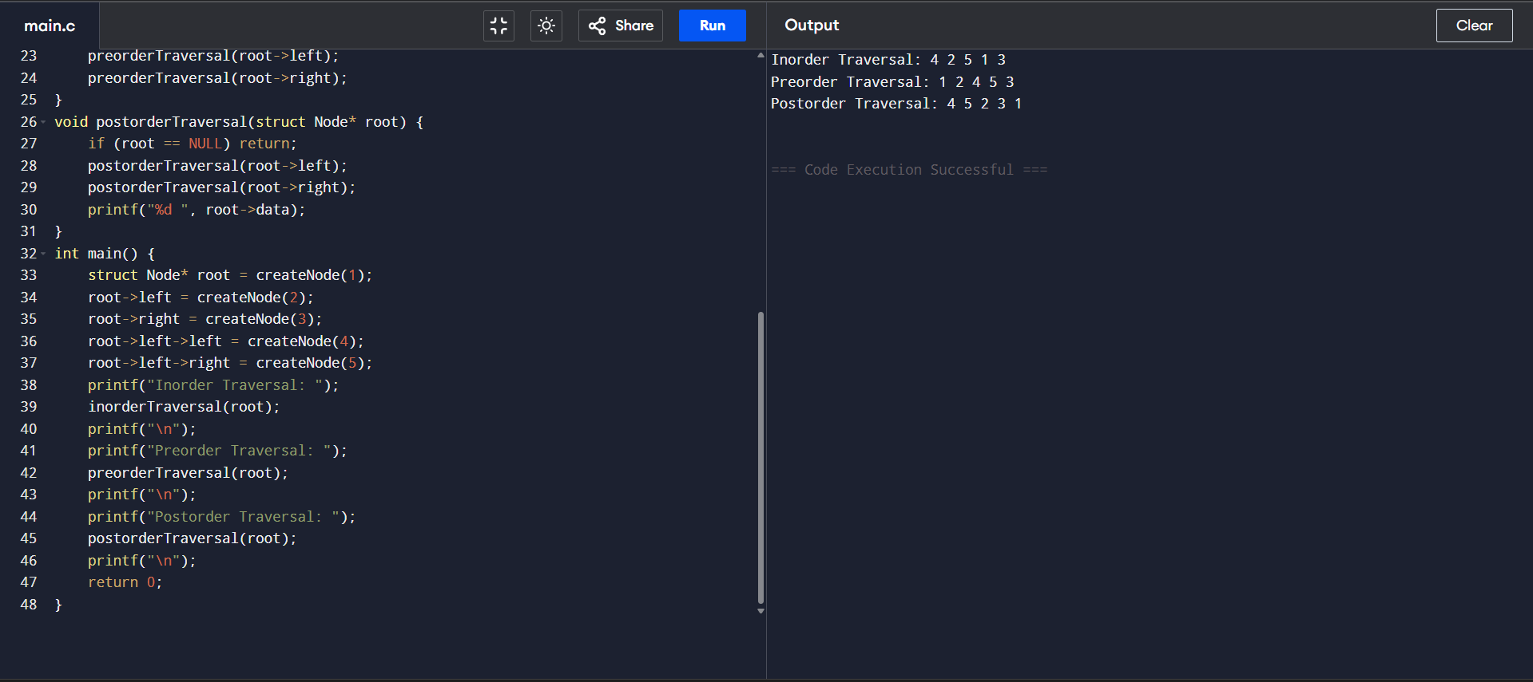

**SAMEER (24/SCA/BCA/042)**

**14.TREE SEARCHING-QUICK SORT**

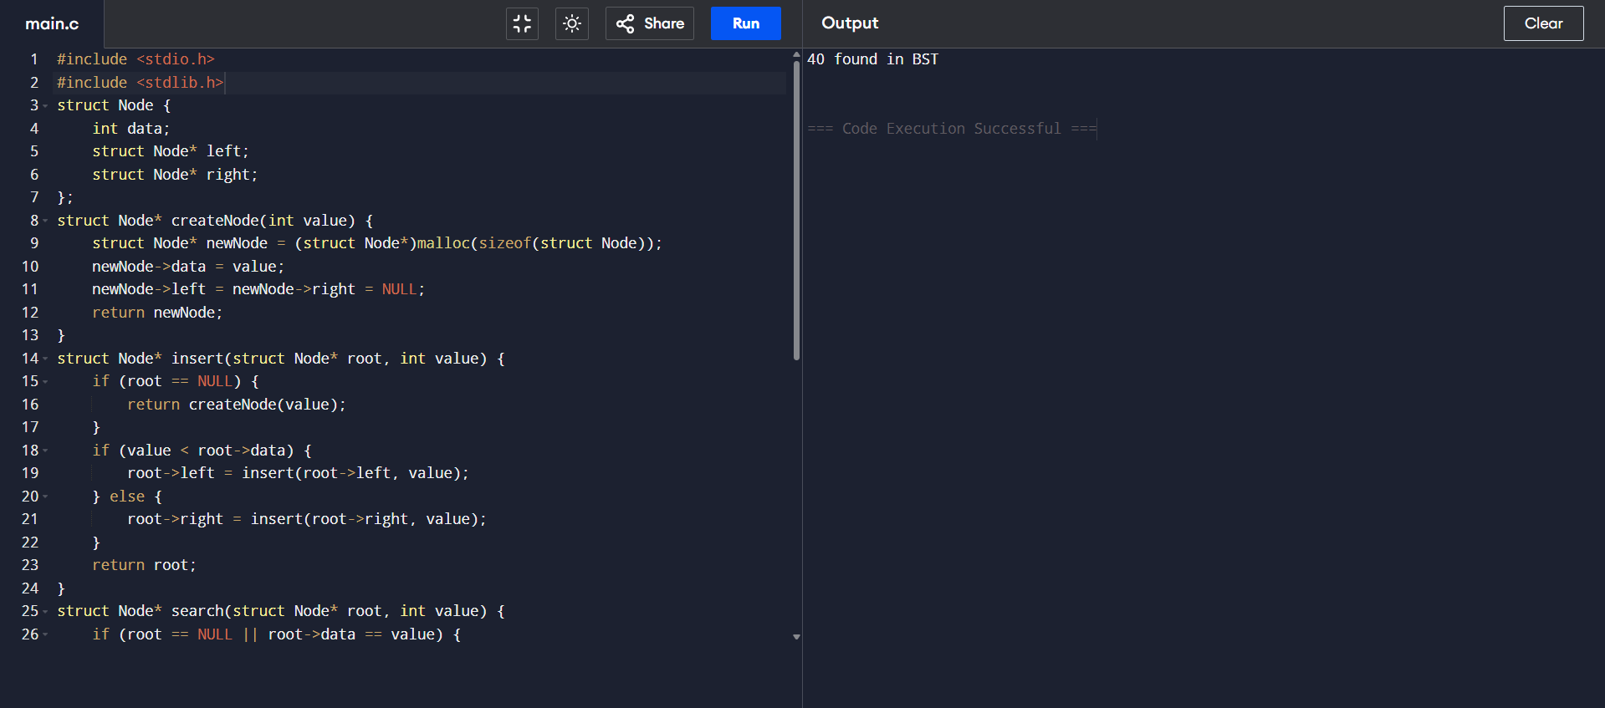

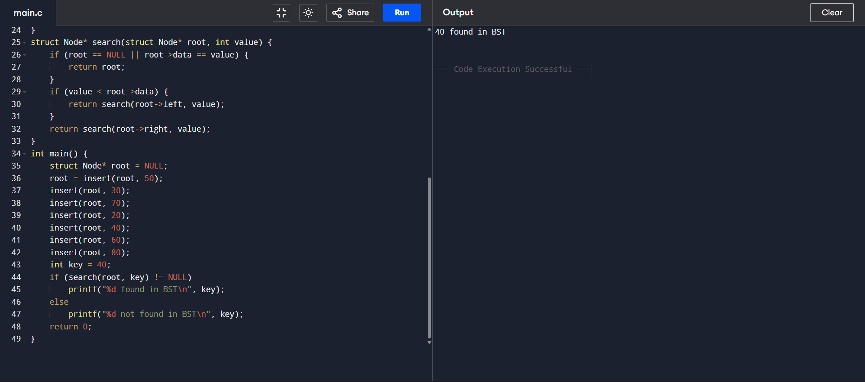

**SAMEER (24/SCA/BCA/042)**

**15.BINARY SEARCH METHOD**

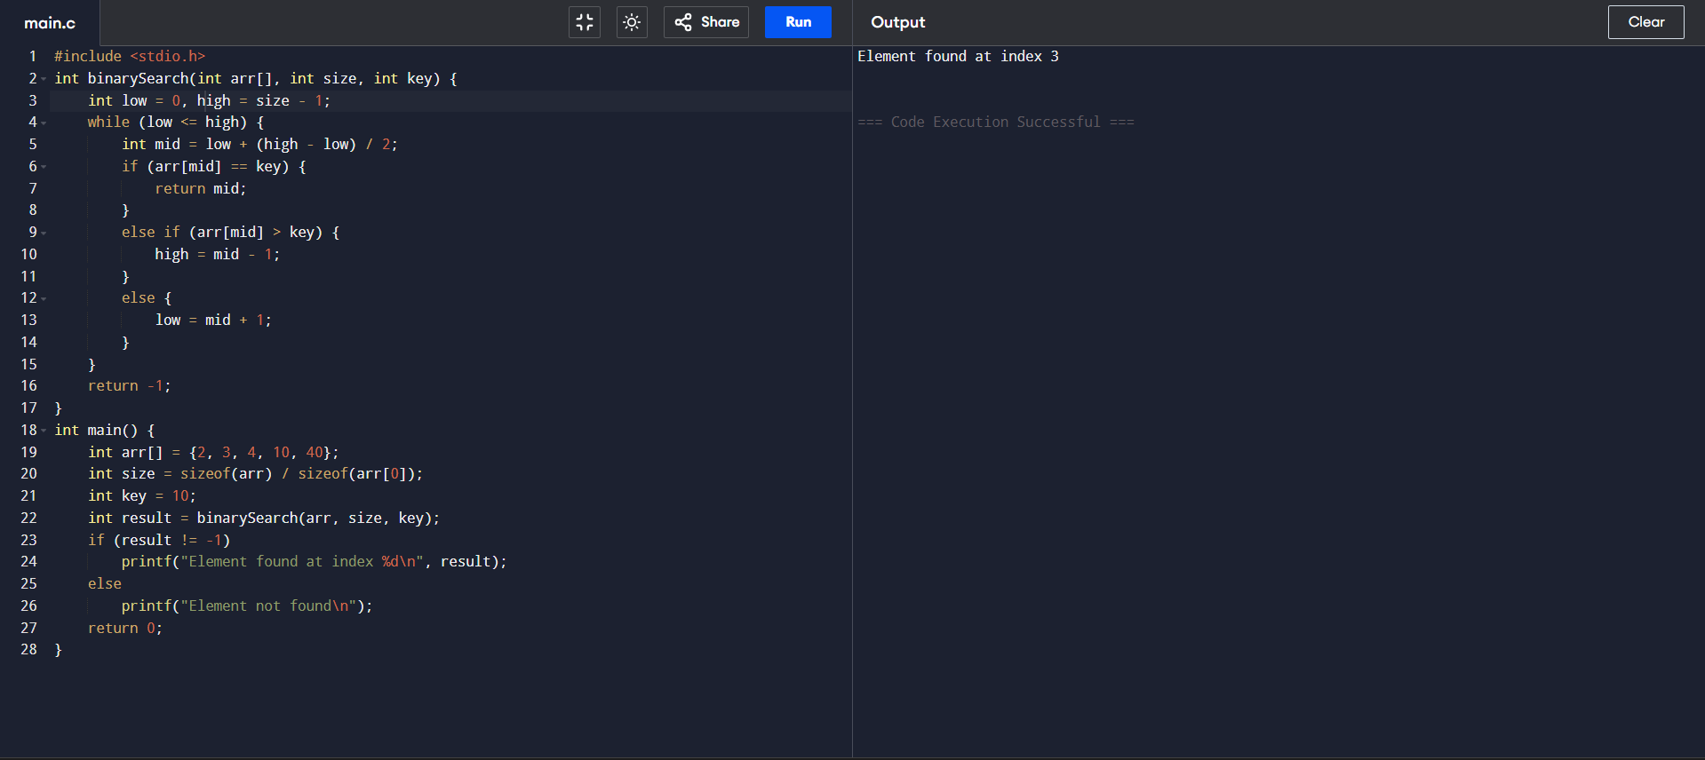

**16.SORTING USING QUICK SORT**

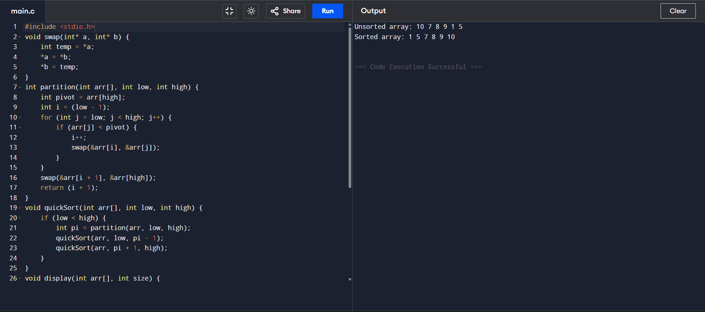

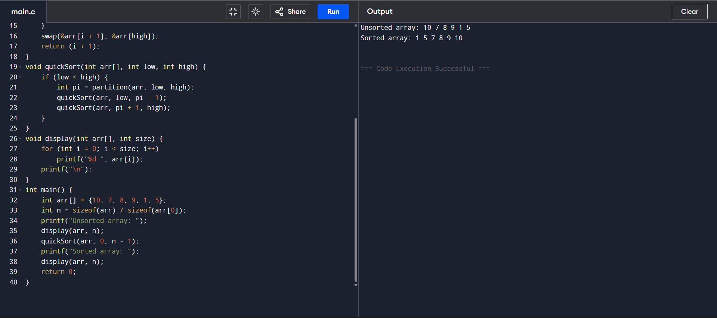

**SAMEER (24/SCA/BCA/042)**

**17.LINEAR SEARCH METHOD**

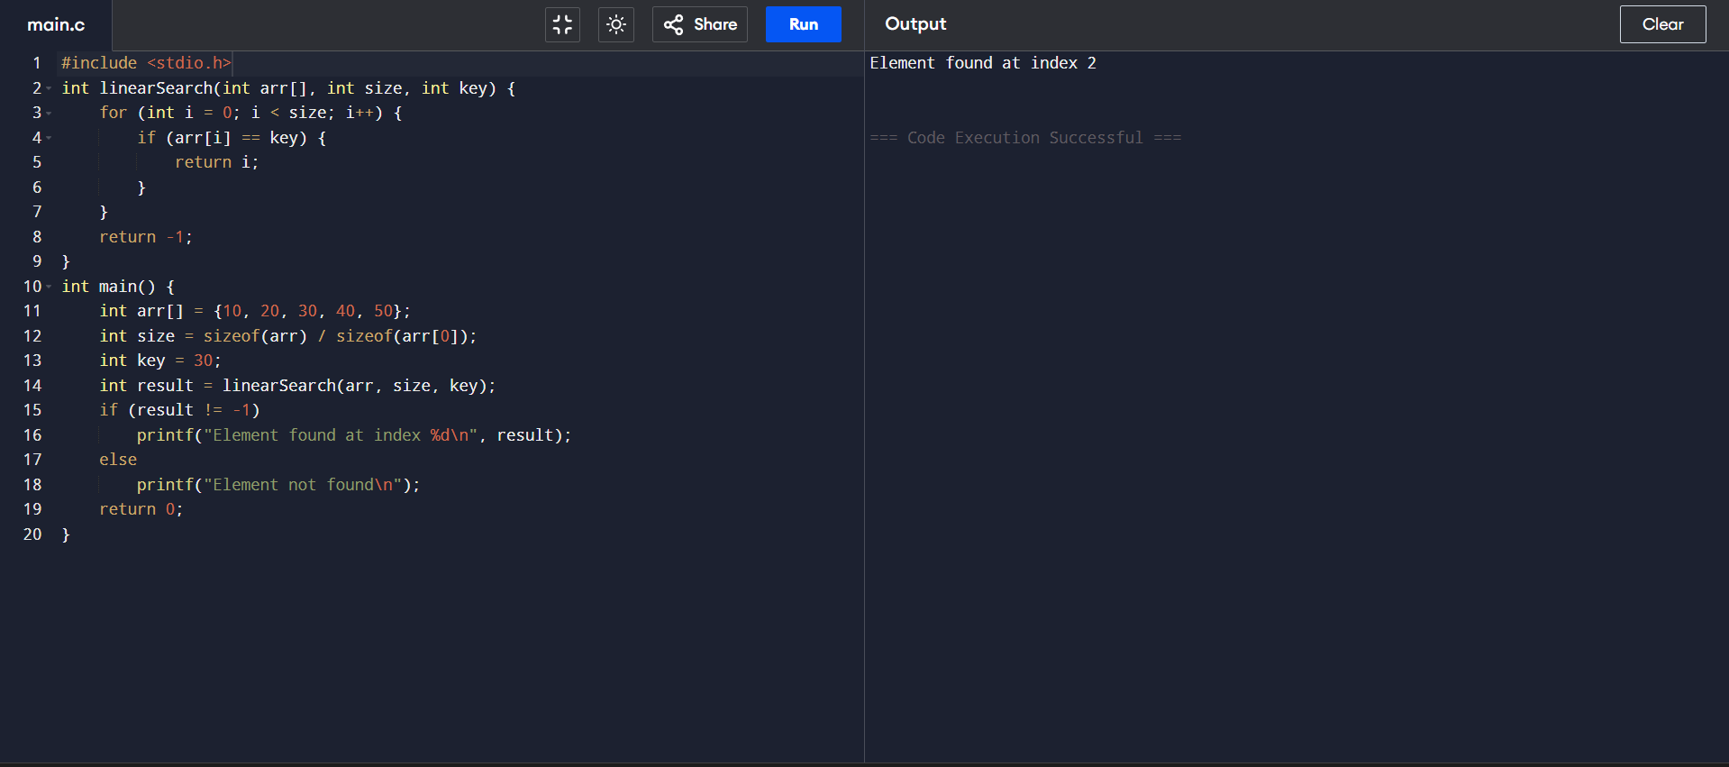

**SAMEER (24/SCA/BCA/042)**

**18.CONCATENATION OF 2 LINKED LISTS**

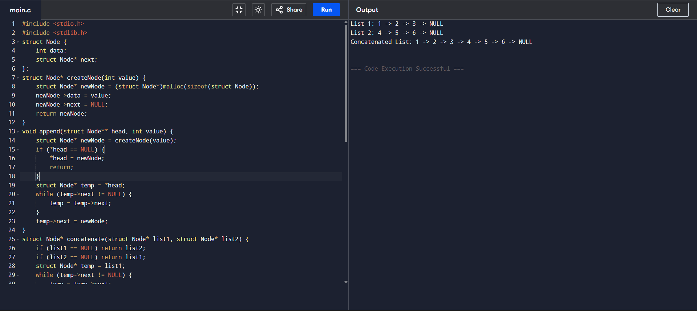

**SAMEER (24/SCA/BCA/042)**

**19.REVERSE OF A LINKED LIST**

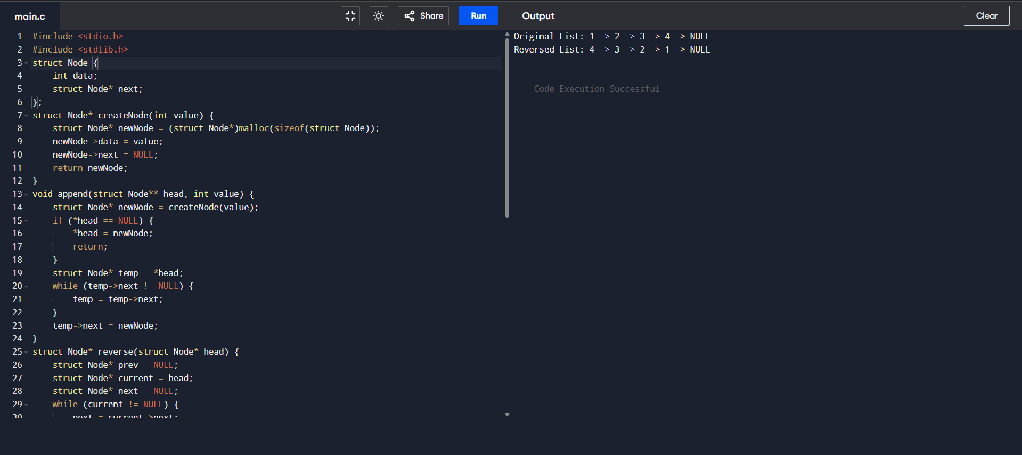

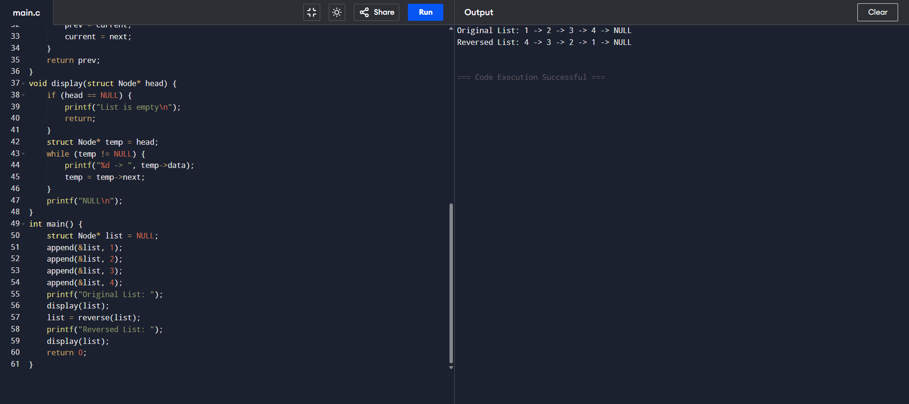

**SAMEER (24/SCA/BCA/042)**

**20.SORTING USING MERGE SORT**

